# Fully Dressed Use Cases

## Create Reservation

Use Case Name: Create Reservation

Description: Used by Club BAIST Members to reserve a tee time.

Stakeholders: Club BAIST Members

Actors: Club BAIST Member

Pre-conditions: The person using this use case must be authenticated and authorized as one of the actors listed above. The tee time must be available (not previously reserved, not during a tournament, not outside of Club BAIST hours).

Success: The tee time will be marked as reserved by the Club BAIST Member

Main Scenario:

1. The Club BAIST Member loads the reservation UI.
2. The system validates that the Club BAIST Member has been authorized to reserve tee times.
3. The Club BAIST Member is presented with a list of tee times for the current week. Available tee times are shown in green and unavailable times are shown in red.
4. The Club BAIST Member can advance to the next week or go back to the previous week.
5. The Club BAIST Member selects a tee time.
6. The Club BAIST Member then enters the names of the players who will be participating. The Club BAIST Members name will automatically be filled in the first slot. Up to 4 players total per tee time.
7. The system will then display UI allowing the Club BAIST Member to confirm or cancel the tee time.
8. The Club BAIST Member confirms the tee time.
9. The system performs another check to ensure the Club BAIST Member is in good standing and that the tee time is available.
10. The tee time is marked as reserved in the system.
11. The system displays a confirmation to the Club BAIST Member.

Extensions:

1. If the Club BAIST Member is not authorized to reserve tee times then the system will display an error message and the Club BAIST Member will not be allowed to reserve tee times.
2. If the tee time is unavailable an error will be displayed describing the reason why. The Club BAIST Member will be able to select another tee time.
3. If the Club BAIST Member cancels they will be taken back to select another tee time. The names of the players will be stored in temporary memory instead of being cleared.
   1. If the Club BAIST Member is not in good standing an error will be displayed. The reservation will not complete.
   2. If the tee time is no longer available an error will be displayed. The Club BAIST Member will be allowed to select another tee time.
4. If the reservation fails in the system an error will be displayed describing why. The Club BAIST Member will be allowed to retry or be given the phone number for the Club BAIST Front Office.

Special Requirements:

* The loading of the weekly calendar view must take less than 0.5 seconds.
* The final confirmation step must take less than 0.5 seconds.
* The system cannot allow multiple Club BAIST Members to reserve the same tee time.

### UI Prototype

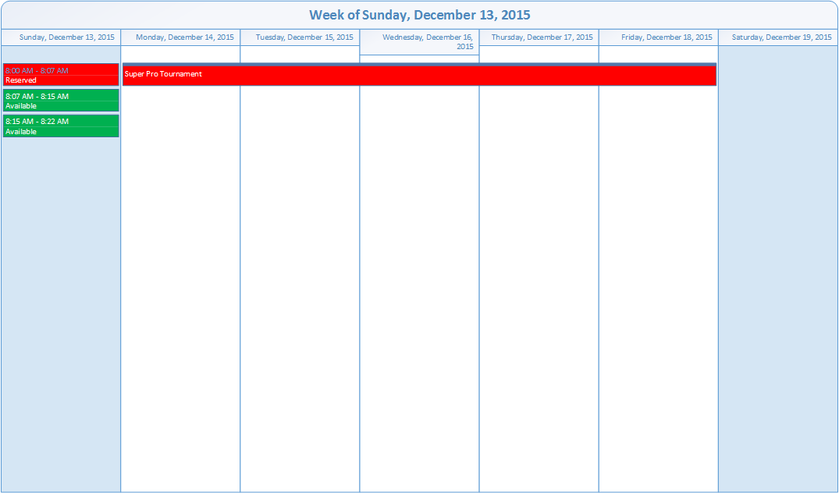

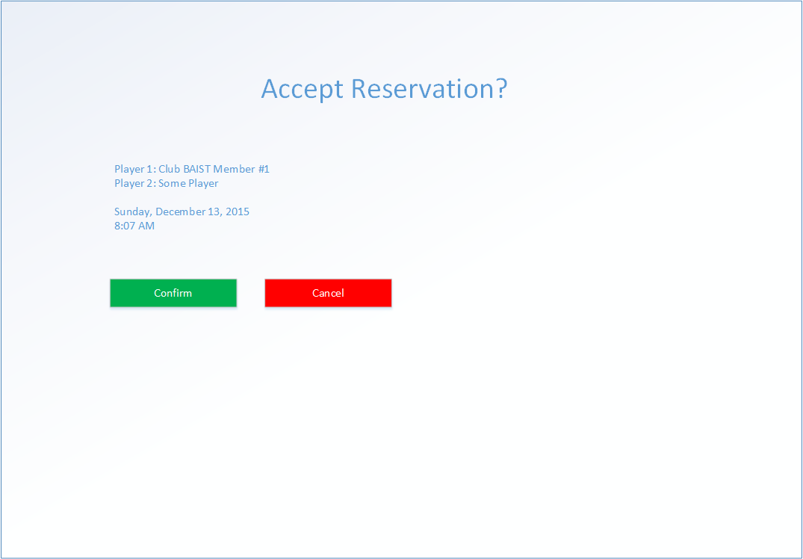

### System Sequence Diagram

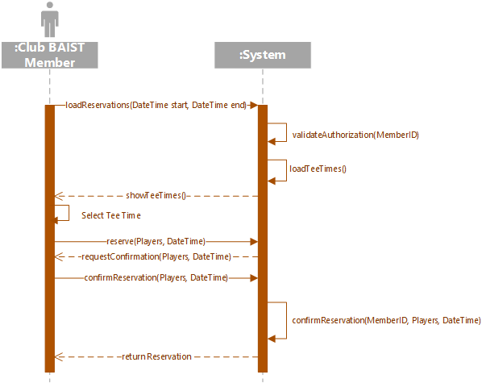

## Cancel Reservation

Use Case Name: Cancel Reservation

Description: Used by Club BAIST Members to cancel a tee time.

Stakeholders: Club BAIST Members

Actors: Club BAIST Member

Pre-conditions: The person using this use case must be authenticated and authorized as one of the actors listed above. The Club BAIST Member must have reservations to cancel.

Success: The tee time will no longer be marked as reserved by the Club BAIST Member.

Main Scenario:

1. The Club BAIST Member loads the cancellation UI.
2. The Club BAIST Member is presented with a list of upcoming reserved tee times belonging to that Club BAIST Member.
3. The Club BAIST Member selects one of the tee times from the list.
4. The system presents dialog asking the Club BAIST Member to confirm their selection.
5. The Club BAIST Member confirms the cancellation.
6. The system marks the tee time as available.
7. A confirmation is displayed to the Club BAIST Member.

Extensions:

1. If the Club BAIST Member has no upcoming tee times a message will be displayed instead.
2. If the Club BAIST Member cancels, the tee time will remain reserved. The Club BAIST Member will be allowed to select another tee time (#2).

Special Requirements:

* The loading of the list of upcoming reserved tee times must take less than 0.5 seconds.
* The final cancellation must take less than 0.5 seconds.

### UI Prototype

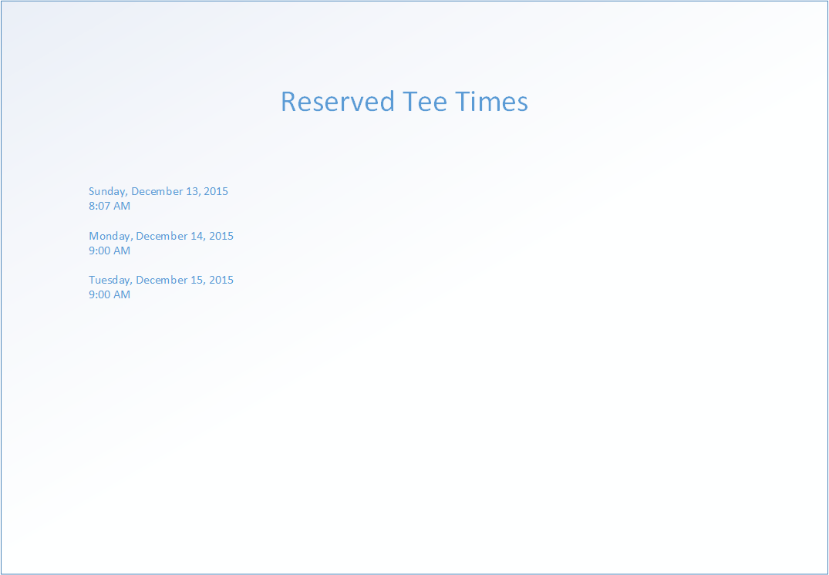

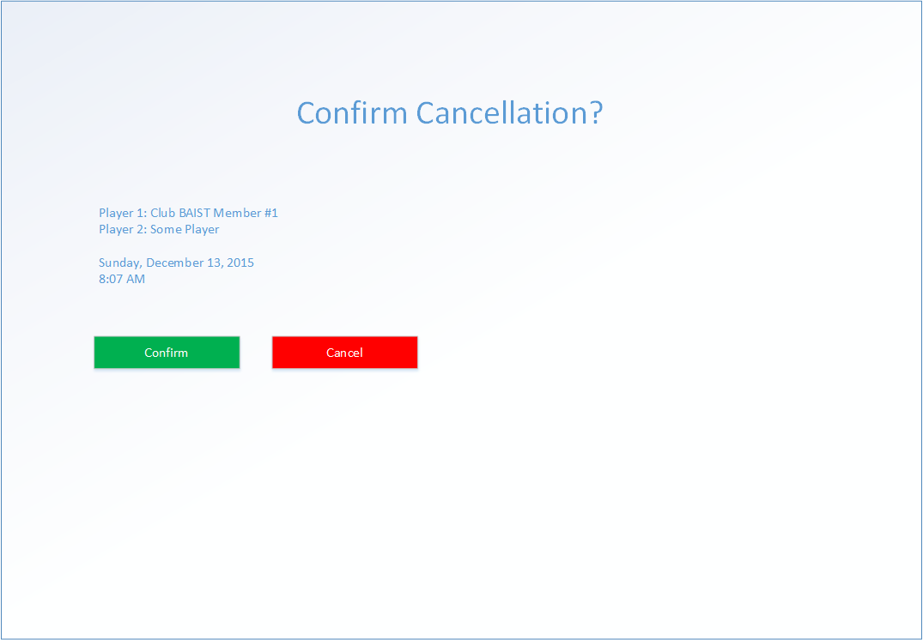

### System Sequence Diagram

